Image Citation

Image 1 example: City Development

<https://www.freeimages.com/photo/city-development-1222506>

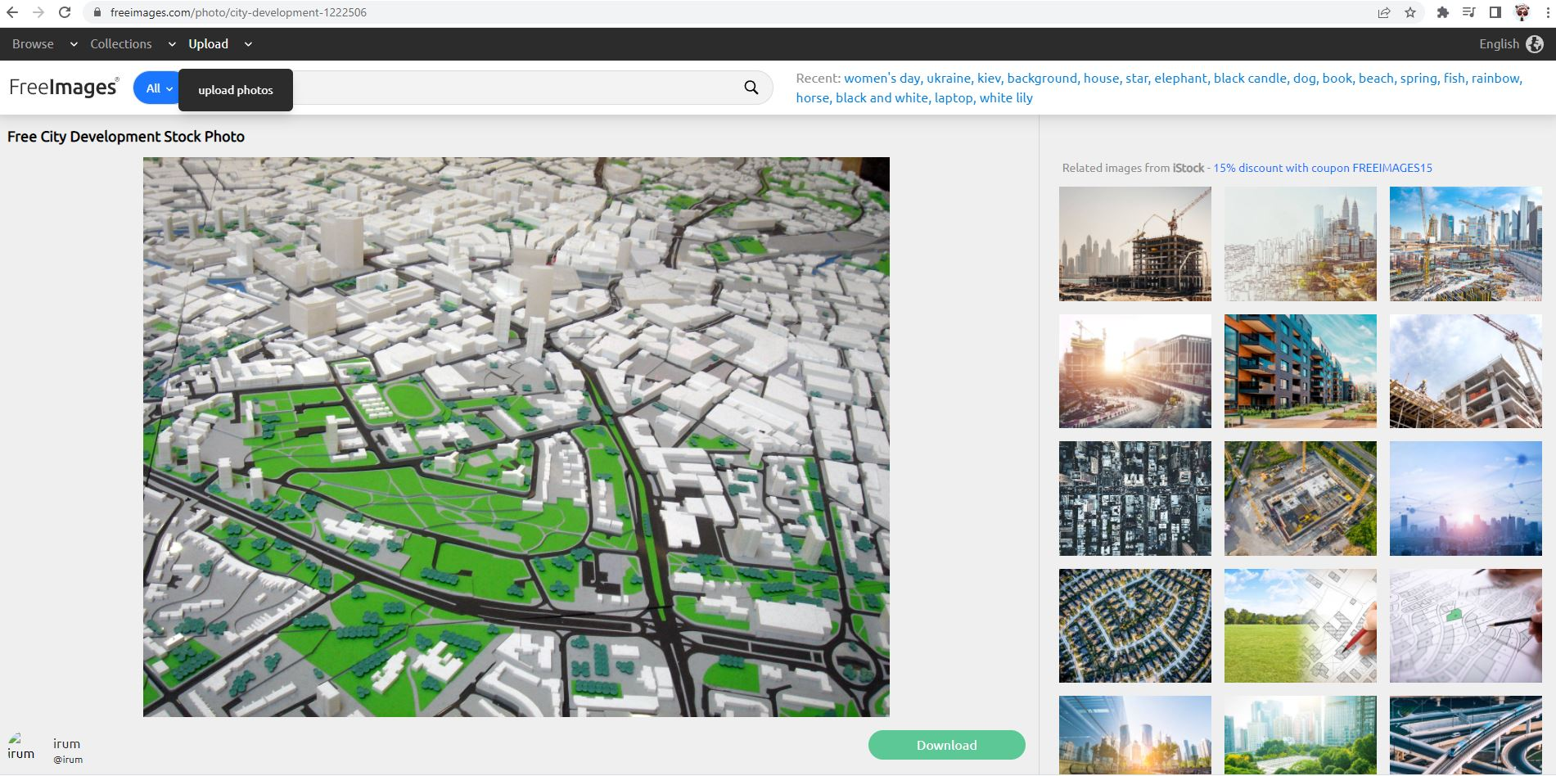

Image 2 example: Brisbane City

<https://www.freeimages.com/photo/brisbane-city-1224451>

